Table of Content
Chapters | Particulars |  |  |  | Page no.
1 | Introduction |  |  |  | 4
1 | 1.1 | Purpose
1 | 1.1 | 1.1.1 |  | Enhance Business Processes | 4
1 | 1.1 | 1.1.2 |  | Division of fields into plots based on partner | 4
1 | 1.1 | 1.1.3 |  | Maintaining Records of inputs and growth of each plot | 5
1 | 1.2 | Product Scope |  |  | 5
1 | 1.3 | Problem Definition |  |  | 5
1 | 1.4 | Aim and goals of the system
2 | Overall Description |  |  |  | 6
2 | 2.1 | Product Perspective/ Environment Description |  |  | 6
2 | 2.1 | 2.1.1 | Hardware Interface/ Hardware Specification |  | 6
2 | 2.1 | 2.1.2 | Software Interface/ Software Specification |  | 6
2 | 2.1 | 2.1.3 | Communication Interface |  | 6
2 | 2.2 | User Characteristics |  |  | 6
2 | 2.2 | 2.2.1 | Owner |  | 6
3 | System Planning |  |  |  | 7
3 | 3.1 | Software Engineering Model |  |  | 7
4 | System Specific Requirements |  |  |  | 9
4 | 4.1 | Functional Requirement |  |  | 9
4 | 4.1 | 4.1.1 | Login |  | 9
4 | 4.1 | 4.1.2 | Field Master : To maintain fields and plots |  | 9
4 | 4.1 | 4.1.3 | Raw Material input management |  | 9
4 | 4.1 | 4.1.4 | Attendance management for labors |  | 10
4 | 4.1 | 4.1.5 | Party master (both vendors and dealers) |  | 10
4 | 4.1 | 4.1.6 | Invoice (Both Purchase and sales) |  | 10
4 | 4.1 | 4.1.7 | Reports |  | 10
4 | 4.2 | Non-functional Requirement |  |  | 11
4 | 4.2 | 4.2.1 | Usability |  | 11
4 | 4.2 | 4.2.2 | Security |  | 11
4 | 4.2 | 4.2.3 | Performance |  | 11
4 | 4.2 | 4.2.4 | Availability |  | 11
4 | 4.2 | 4.2.5 | Error Handling |  | 12
4 | 4.2 | 4.2.6 | Ease of Use |  | 12
5 | System Analysis |  |  |  | 5
5 | 5.1 | Use case Diagram(s)
5 | 5.1 | 5.1.1 | Owner |  | 13
5 |  | 5.1.2 | Farm Manager |  | 13
5 | 5.2 | Activity Diagrams |  |  | 14
5 | 5.2 | 5.2.1 | Activity Diagram for adding fields and plots |  | 14
5 | 5.2 | 5.2.2 | Activity Diagram for adding raw materials |  | 15
5 | 5.2 | 5.2.3 | Activity Diagram for adding employees |  | 16
5 | 5.2 | 5.2.4 | Activity diagram for recording employee attendance |  | 17
5 | 5.2 | 5.2.5 | Activity diagram for adding party |  | 18
5 | 5.2 | 5.2.6 | Activity diagram for adding invoice |  | 19
6 | System Design |  |  |  | 20
6 | 6.1 | Database Design |  |  | 20
6 | 6.1 | 6.1.1 | Data Dictionary |  | 20
7 | System Implementation |  |  |  | 24
7 | 7.1 | Screenshots |  |  | 24
8 | Testing |  |  |  | 33
8 | 8.1 | Test Cases |  |  | 33
9 | Future Enhancement |  |  |  | 34
10 | Conclusion |  |  |  | 34
11 | Bibliography |  |  |  | 34

1.Introduction
Agriculture sector is most unmanaged sector in the country. There is little or no digitization in this area. This is so because of the various processes which change from crops to crops and places to places. The current system focuses on every little aspect to manage day to day farm activities. There are various instances where, due to lack of proper data farmers tend to make wrong decisions in matter of raw materials or the normal accounts. Sometimes due to lack of previous data farmers tend to utilize more than required pesticides or due to lack in management. This system will enable farmer to divide his field area into plots of various crops and make the record of each and every raw material used and even maintain the ad-hoc employee register. Attendance records can be managed and various reports for the employees can be generated. Invoicing is the important aspect for any farm, majorly farmers are occupied much in their daily activities that they are not able to manage their accounts. This system enables them to maintain their dealers and vendors and do the invoicing accordingly. This would help to generate various kinds of reports.

Purpose
The advancement in Information Technology and internet penetration has greatly enhanced various business processes and communication between companies (services provider) and their customers of which car rental industry is not left out. Agrologix is developed to provide the following services.

Enhance Business Processes
To lead the farmer to more productive activities instead of occupying themselves in the routine which gradually decreases their efficiency. The power of information technology is new in the area and would help a lot in making digital farms

Division of fields into plots based on partner
When there is large area of field its essential for the farmer to divide its fields into various plots and grow different types of the crops in each plot. Every plot has its own kind of specific requirements like pesticides or the raw materials. Even for the accounting purposes this division into plots plays an important role. As this plots are given to various partners for taking care and they get a commission from it yields.

Maintaining Records of inputs and growth of each plot
Whenever we deal with various kinds of crops which have their own life cycle, it’s very important to know when each and every raw material is used. This records are need to be maintained in order to avoid any over dosage. Yields of every plot can be recorded in order to decide right amount of commission to the plot partner.

Product Scope
The scope of this system is very wide not because it’s physical existence but it’s flexibility to be used in various types of crops.
- This system can be used anywhere where farm activities are carried out.
- Can be used for any crops
- Can be used by owner of the farms. Other users can be manageable as per requirements of the owner.
- This is a desktop based application which means it available 24x7 except the technical errors.

Problem Definition
Agriculture is a sector which is still untouched by IT Sector. Farmers used to maintain records manually and would cause them problem in making decision in various matters. The delay in the process would make the huge losses to them. They would need maintain invoicing manually and even their employee payrolls. The yields of the crop were to be measured on the daily basis which increases the chances of the error.

Aims and goals of the system
- To produce a desktop based application which is used by farmers to record various activities.
- To help making quick and better decisions.
- To maintain accounts of the sales and purchases.

2.Overall Description

2.1 Product Perspective/ Environment Description

2.1.1 Hardware Interface/Hardware Specification
- Any windows machine (Preferably windows 10)
- Minimum 4GB Ram Required
- Laser Jet Printer

2.1.2 Software Interface/ Software Specification
- .Net Framework installed
- Microsoft SQL Server Management Studio
- Printer Drivers

2.1.3 Communication Interface
- printers

2.2 User Characteristics
- Farmer/owner:
        - Can login to the system
        - Maintain fields and the plots
        - Maintain raw materials and their categories
        - Maintain the labors/Employees
        - Record the attendance of the labors
        - Records yields from the fields
        - Maintain the party master
        - Invoicing: Sales and Purchase

3. System Planning

3.1 Software Engineering Model
Waterfall Model
We have followed this model step is…
1. Requirement Analysis
2. Design
3. Implementation
4. Unit Testing
5. Integration and Testing
6. Deployment and Maintenance
- The waterfall model begins with the system. It gathers requirements from the customer. At the end SRS and software project plan are produced. The SRS acts as a contract between the customer and the developer. In the design phase, the SRS is transformed into design which is suitable for implementation in a programming language. First preliminary design is made then detailed design is m initial test plan are produced at the end of this phase
- During the implementation phase.
- In unit testing small modules are tested in isolation and the overhead code is written for handling communication amongst these modules.
- After implementation and unit testing, the modules are integrated to form a complete system. Integration and testing are carried out to verify the functionality of the system.
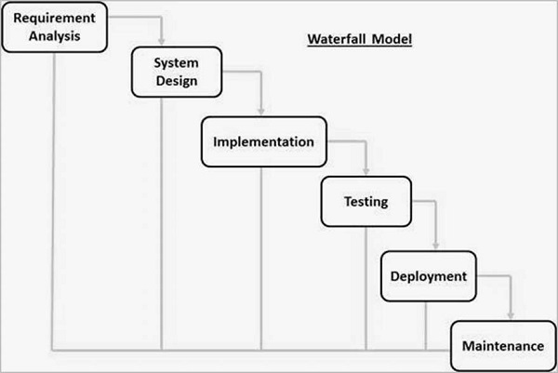

4.System Specific Requirements

4.1 Functional Requirements
These are statements of services the system should provide, how the system should react to particular inputs, and how the system should behave in particular situations. It specifies the application functionality that the developers must build into the product to enable users to accomplish their tasks

4.1.1 Login
- This should allow the owner to execute or farm executive to login to the system.

4.1.2 Field Master: To maintain fields and plots
- This should allow the owner/Farm executive to manage the number of which the owner has.
- This should allow the owner/Farm executive to manage the number of plots that are divided from fields.
- This should allow to manage the which crops are grown into which plot.
- This should allow to manage who is the partner of the particular plot.

4.1.3 Raw Material input management
- This should allow the owner/Farm executive to manage categories of raw material.
- This should allow the owner/Farm executive to manage raw material product category wise.
- This should allow the owner/Farm executive to manage price and unit of every raw material product.
- This should allow the owner/Farm executive manage the input given to each plot.

4.1.4 Attendance management for labors
- This should allow the owner/Farm executive to manage the extra labors they hire temporarily
- This should allow the owner/Farm executive to manage the attendance for each labor everyday field and plot wise.

4.1.5 Party master (both vendors and dealers)
- This should allow the owner/Farm executive to manage their vendors(Purchase).
- This should allow the owner/Farm executive to manage their dealers(Sales).

4.1.6 Invoice (Both Purchase and sales)
- This should allow the owner/Farm executive to manage purchase of raw materials
- This should allow the owner/Farm executive to manage sales of crop yields
- This should allow manager to maintain a total record of crop yield in a plot.

4.1.7 Reports
- This should allow the owner/Farm executive to generate labor wise attendance report.
- This should allow the owner/Farm executive to generate plot wise labor attendance report.
- This should allow the owner/Farm executive to generate total stock report.
- This should allow the owner/Farm executive to generate sales report.
- This should allow the owner/Farm executive to generate purchase report.
- This should allow the owner/Farm executive to generate plot wise input report.

4.2 Non Functional Requirements
Non-functional requirements, as the name suggests, are requirements that are not directly concerned with the specific services delivered by the system to its users. They may relate to emergent system properties such as reliability, response time, and store occupancy. Alternatively, they may define constraints on the system implementation such as the capabilities of I/O devices or the data representations used in interfaces with other systems. Non-functional requirements, such as performance, security, or availability, usually specify or constrain characteristics of the system as a whole.

4.2.1 Usability
The system provides a help and support menu in all interfaces for the user to interact with the system. The user can use the system by reading help and support.

4.2.2 Security
The system provides username and password to prevent the system from unauthorized access. The staffs’ password must be greater than eight characters. The subsystem should provide a high level of security and integrity of the data held by the system, only authorized personnel of the company can gain access to the company’s secured page on the system; and only users with valid password and username can login to view user’s page.

4.2.3 Performance
The system response time for every instruction conducted by the user must not exceed more than a minimum of 10 seconds. The system should have high performance rate when executing user’s input and should be able to provide response within a short time span usually 50 second for highly complicated task and 20 to 25 seconds for less complicated task.

4.2.4 Availability
The system should always be available for access at 24 hours, 7 days a week. Also in the occurrence of any major system malfunctioning, the system should be available in 1 to 2 working days, so that business process is not severely affected.

4.2.5 Ease of use
Considered the level of knowledge possessed by the users of this system, a simple but quality user interface should be developed to make it easy to understand.

4.2.6 Error Handling
Error should be considerably minimized and an appropriate error message that guides the user to recover from an error should be provided. Validation of user’s input is highly essential. Also the standard time taken to recover from an error should be 15 to 20 seconds.

5.System Analysis

5.1 Use Case Diagrams
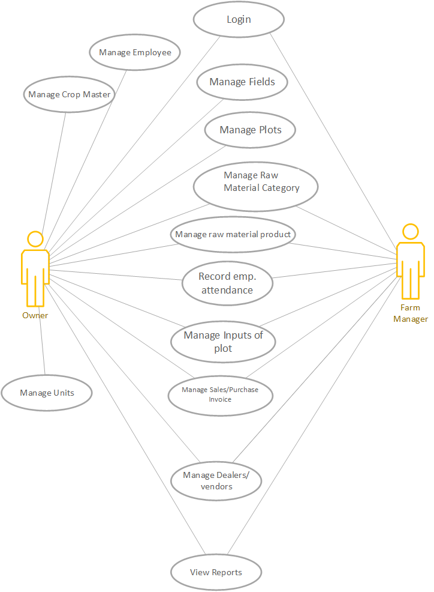

5.2 Activity Diagrams

5.1.1 Activity Diagram for adding fields and plots
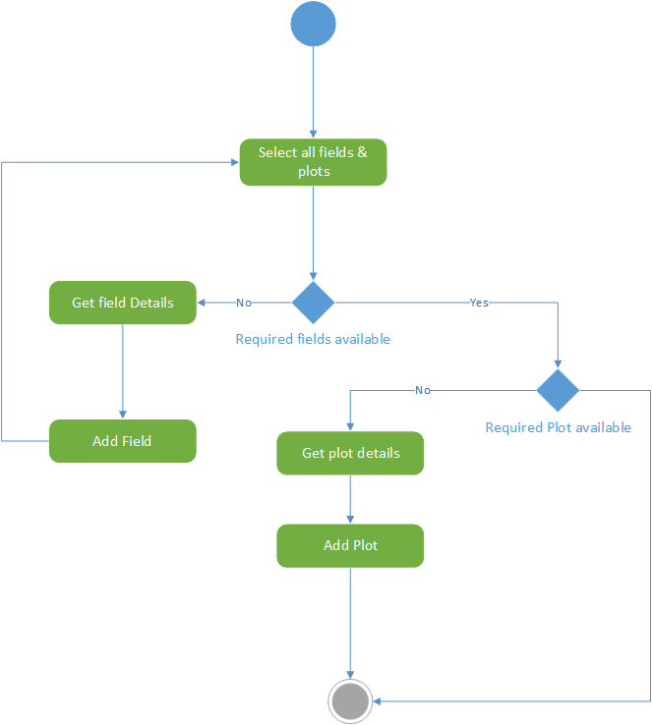

5.1.2 Activity Diagram for adding raw materials
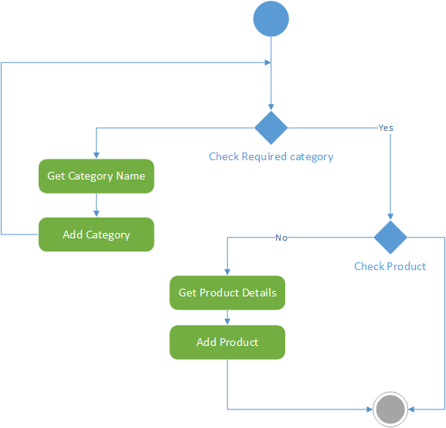

5.1.3 Activity Diagram for adding Labor
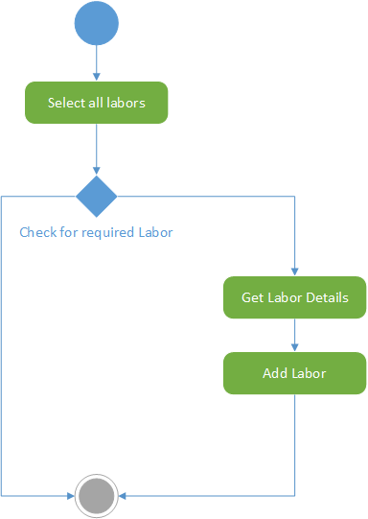

5.1.4 Activity diagram for recording labor attendance

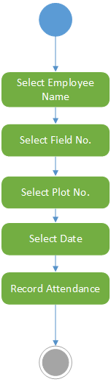

5.1.5 diagram for adding Party
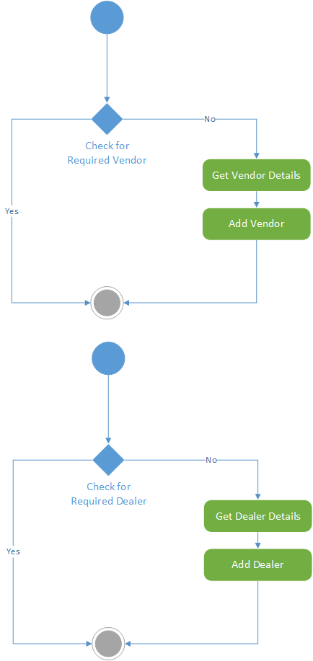

5.1.6 Activity diagram for adding invoice
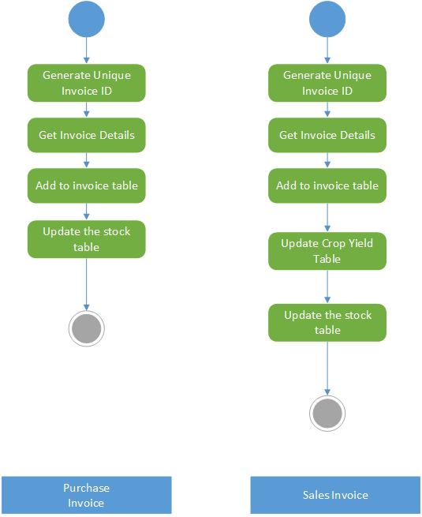

6.System Design

6.1 Database Design

6.1.1 Data Dictionary
Table Name : | Field Master
Attribute Name | Data Type | Size | Constraint | Description
F_number | Int | 2 | Primary Key | Stores the field No.
F_Area | decimal |  | Not Null | Stores field area

Table Name : | Plot Master
Attribute Name | Data Type | Size | Constraint | Description
f_number | int | 2 | FK-Field Master | Stores field no.
plotid | int | 2 | Primary Key | Stores Plot no.
plotarea | decimal |  | not null | Stores Plot area
Partner Name | Varchar | 25 | not null | Stores partner name
crop type | varchar |  | FK-Crop Master | Stores crop type

Table Name : | Crop Master
Attribute Name | Data Type | Size | Constraint | Description
cropid | Int | 2 | Primary Key | Stores the crop ID
crop_name | varchar | 20 | not null unique | Stores crop name

Table Name : | rm_purchase Master
Attribute Name | Data Type | Size | Constraint | Description
billid | Int | 6 | Primary Key | Stores Bill ID
date | Date |  | not null | Stores date
vendorid | Int | 3 | FK-vendor Master | Stores VendorID
vendorbill_no | Int | 6 | not null | Stores Vendor Bill No
vendorname | varchar | 25 | FK-vendor Master | Store name of vendor
rm_cat | varchar | 20 | FK-rm_category Master | Store RM Category
rm_product | varchar | 20 | not null | Stores RM Product name
rm_unit | varchar | 15 | FK-rm_product Master | Stores unit of product
qty | int | 10 | not null | Stores quantity
amount | int | 10 | not null | Stores final amount of product

Table Name : | emp Master
Attribute Name | Data Type | Size | Constraint | Description
empid | Int | 5 | Primary Key | Stores employee ID
empname | varchar | 20 | not null | Stores Emp. Name
empphone | varchar | 10 | unique | Stores Emp. Phone

Table Name : | crop_stock
Attribute Name | Data Type | Size | Constraint | Description
stid | Int | 10 | Primary Key | Stores crop ID
fieldno | Int | 2 | FK-Field master | Stores Field No.
plotno | int | 2 | FK-Plot Master | Stores Plot No.
crop_name | varchar | 20 | FK-Crop Master | Stores Crop Name
qty | Int | 10 | not null | Stores Quantity

Table Name : | Sales
Attribute Name | Data Type | Size | Constraint | Description
invoiceid | int | 6 | Primary Key | Stores Invoice ID
Date | date |  | not null | Stores Date
Dealer_name | varchar | 25 | FK-Dealer Master | Stores Dealer Name
dealerid | int | 3 | FK-Dealer Master | Stores Dealer ID
fieldno | int | 2 | FK-Field master | Stores Field No
plotno | int | 2 | FK-Plot Master | Stores Plot No
qty | int | 10 | not null | Stores Quantity
amount | int | 10 | not null | Stores Amount

Table Name : | Unit Master
Attribute Name | Data Type | Size | Constraint | Description
unit_id | int |  | Primary Key | Stores Unique ID
unit | varchar(20) |  | Not Null,Unique | Stores Unit name

Table Name : | dealer Master
Attribute Name | Data Type | Size | Constraint | Description
dealerid | int | 3 | Primary key | Stores Dealer ID
dealer_name | varchar | 25 | Not null | Stores Name of dealer
dealer_city | varchar | 15 | Not null | Stores city of dealer
dealer_phone | varchar | 10 | Not null | Stores phone number of dealer

Table Name : | empatt Master
Attribute Name | Data Type | Size | Constraint | Description
aid | int | 5 | Primary Key | Stores unique ID
empid | int | 5 | FK-emp Master | Stores Employee ID
empname | varchar | 20 | FK-emp Master | Stores Employee Name
fieldno | int | 2 | FK-Field master | Stores field no
plotno | int | 2 | FK-Plot Master | Stores plot no

Table Name : | rm_plotinput
Attribute Name | Data Type | Size | Constraint | Description
inputid | int | 2 | Primary Key | Stores unique ID
fieldno | int | 2 | FK-Field Master | Stores field no
plotno | int | 2 | FK-Plot Master | Stores Plot No
rmcat | vachar | 20 | FK-rm_category Master | Stores RM Category
rm_product | varchar | 20 | FK-rm_product Master | Stores RM Product
qty | int | 10 | not null | Stores Quantity
unit | varchar | 10 | not null | Stores Unit

Table Name : | vendor Master
Attribute Name | Data Type | Size | Constraint | Description
vendorid | int | 3 | Primary key | Stores unique ID
vendor_name | varchar | 25 | Not null | Stores vendor name
vendor_city | varchar | 15 | Not null | Stores vendor city
vendor_phone | varchar | 10 | Not null | Stores vendor phone number

Table Name : | rm_product Master
Attribute Name | Data Type | Size | Constraint | Description
rmp_id | int | 3 | Primary Key | Stores Unique ID
rm_cat | varchar | 20 | FK-rm_category Master | Stores RM Category
rm_product | varchar | 20 | not null unique | Stores RM Product name
rm_unit | varchar | 15 | unique | Stores Unit Product
price | decimal |  | not null | Store Price

Table Name : | rm_category Master
Attribute Name | Data Type | Size | Constraint | Description
rmid | int | 3 | Primary Key | Stores Unique ID
rmcat | vachar | 20 | Not null unique | Stores RM Category

7.System Implementation

7.1 Screen shots
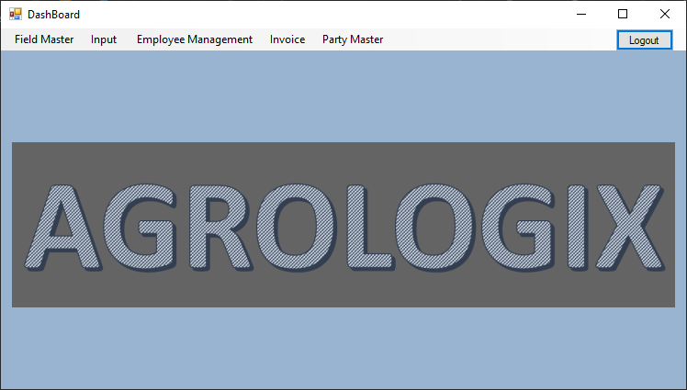
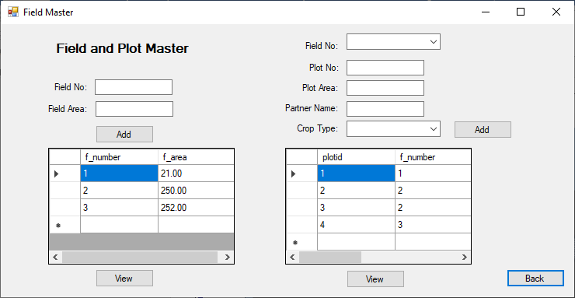
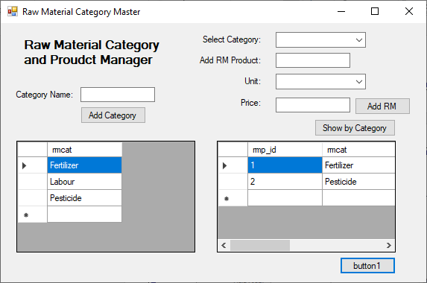

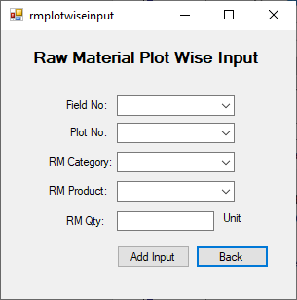

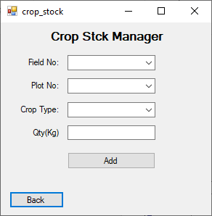
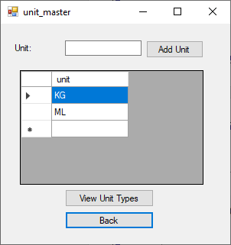

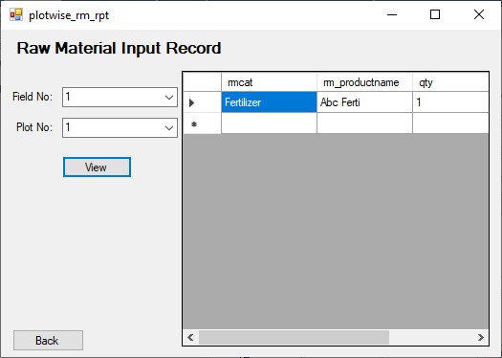
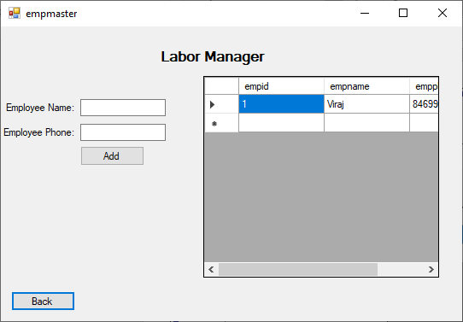
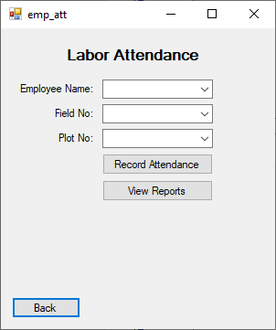
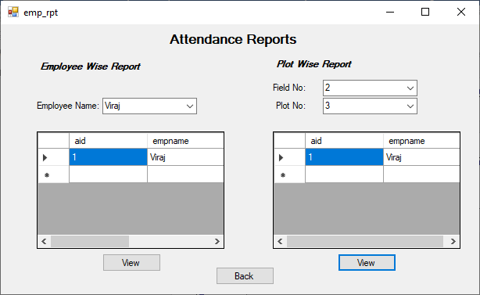

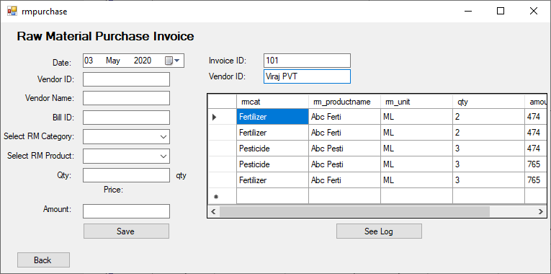
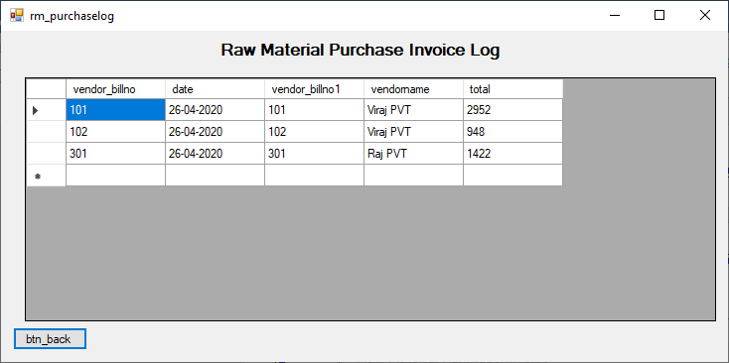

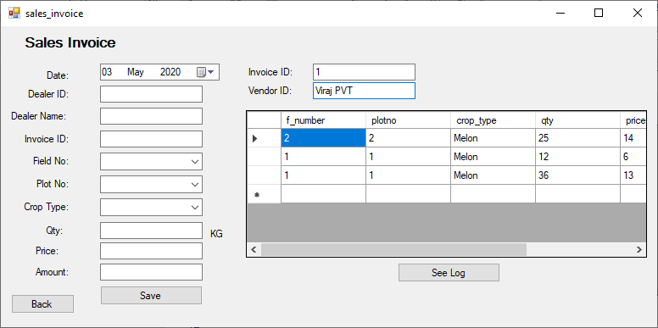
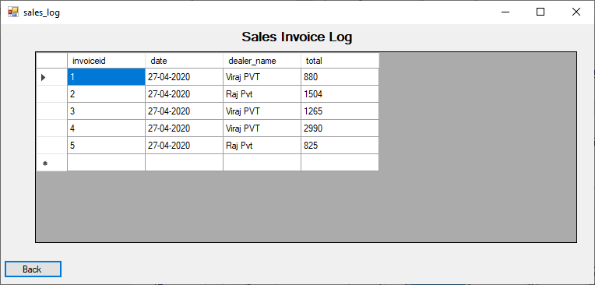

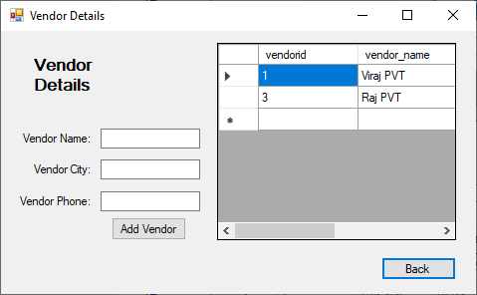
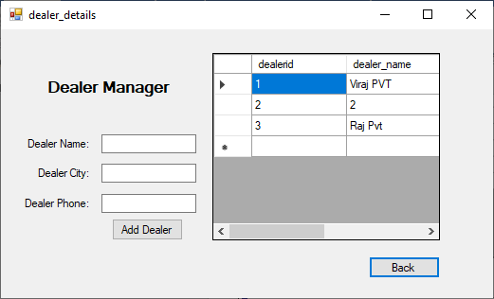

8.Testing

8.1 Test cases
1 | All files are empty | Error message:*indicates compulsory field* | Error message:*indicates compulsory field* | Pass
2 | Email | Error message: Invalid Email-address | Email Accepted | Fail
3 | Password and confirm password | Error message: Both Password does not match | Error message: Both Password does not match | Pass
4 | Login | Login to the system should be try with the login assigned by the admin and the correct password | Login should be successful and the user should enter into the system | Fail
 |  | The System give an error and denied from the Login. | Login should fail with an error ‘Invalid Details’ | Pass
5 | User | Login should be allow and admin get Admin home page | Login successfully and admin get its admin home page | Pass
 |  | Login should be allow and Travel admin get Travel admin home page | Login successfully and Travel admin get its Travel admin home page | Pass
 |  | Login should be allowing and User get Visitor Side User page. | Login successfully and User gets its user page. | Pass
6 | Validation Test cases | Pre-define format must be required in control | System give error to enter valid input | Pass
 |  | Enter data in a compulsory field with required field validations. | Data must be field in compulsory field otherwise its messages are displayed. | Pass

9.Future Enhancements
We believe that every system has a chance of improvement and we have already found out and set up the next milestone to our system
- We would like to add a feature which would advise the farmer that which raw material is required now according to schedule feed inside.
- We would like to enhance our accounting system more to accommodate ledgers and profit & Loss statements
- We would like to upgrade our system to a better UI system and more personalization to the system.

10.Conclusions
Agriculture in today’s world have reached a new height. There are modern techniques which truly takes this business global. Every activity related to agriculture is still physical and manual from farms to customers, everything is unorganized. Farmers distract themselves from productive routine to this repetitive work. So this AGROLOGIX would help farmers to manager their farm activities with the power of information technology. When we talk about information technology which talk about smart systems which smartly stores the information and process them to give output. Here as a result of this system farmer is powered to make the right decisions and get rid of the tedious task which takes time.

11.Bibliography
1. Yogesh Singh, Ruchika Malhotra, “Object-Oriented Software Engineering” – PHI.
2. Mall R., Fundamental of Software Engineering, PHI

